**1. Explain the advantages and limitations of using JavaScript for client-side scripting.**

=> **Advantages of javascript**

1. Less server interaction
2. Immediate feedback to the visitors
3. Increased interactivity
4. Richer interfaces

=> **Limitations of JavaScript**

We cannot treat JavaScript as a full-fledged programming language. It lacks the following important features –

* Client-side JavaScript does not allow the reading or writing of files. This has been kept for security reason.
* JavaScript cannot be used for networking applications because there is no such support available.
* JavaScript doesn't have any multi-threading or multiprocessor capabilities.

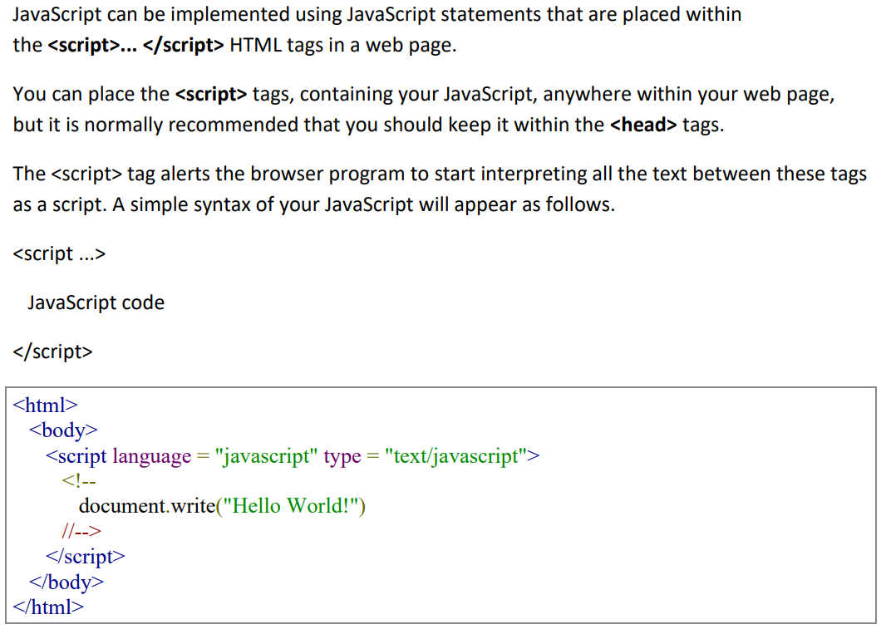

**2. Discuss the various methods and properties available in the Math object in JavaScript.**

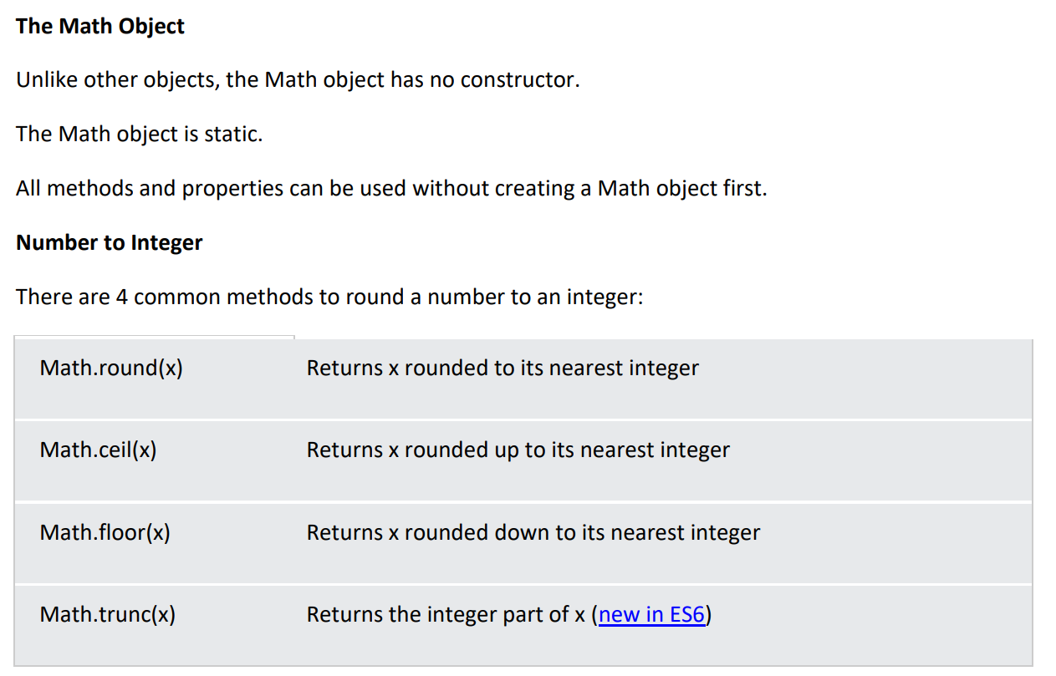

**3) How does the DOM tree represent an HTML document, and how can JavaScript manipulate it?**

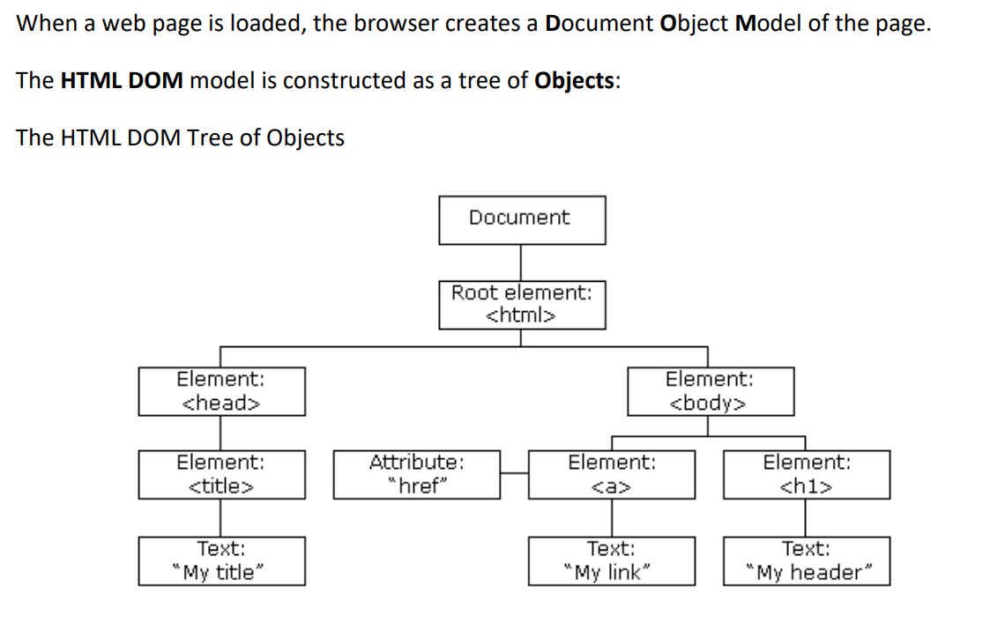

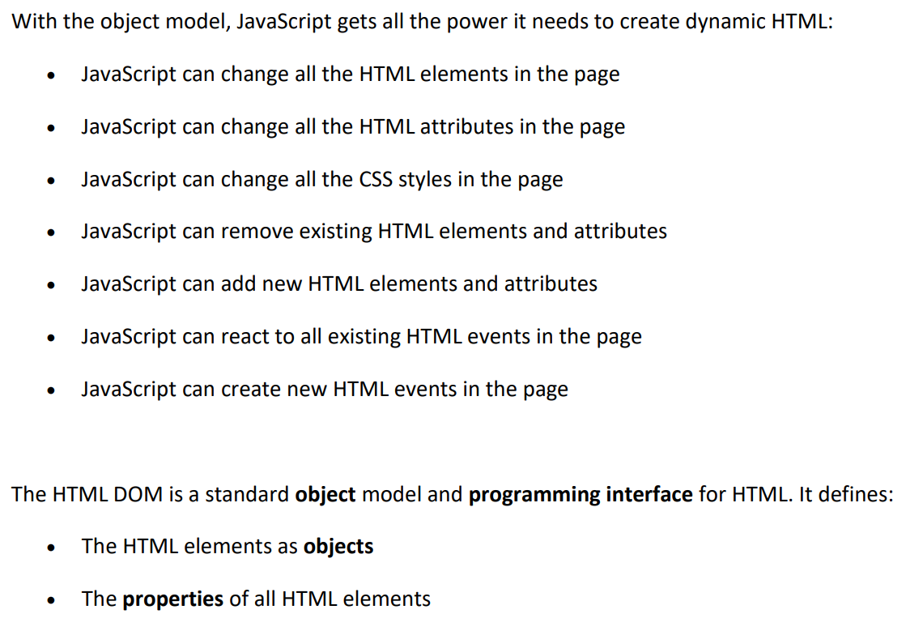

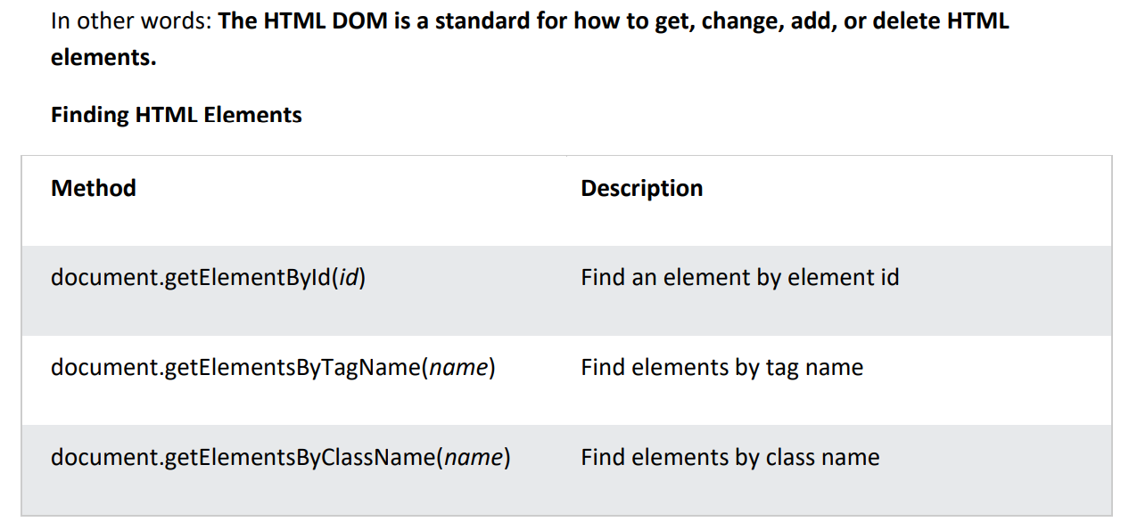

**4. Describe the difference between for, while, and do-while loops in JavaScript, with examples.**

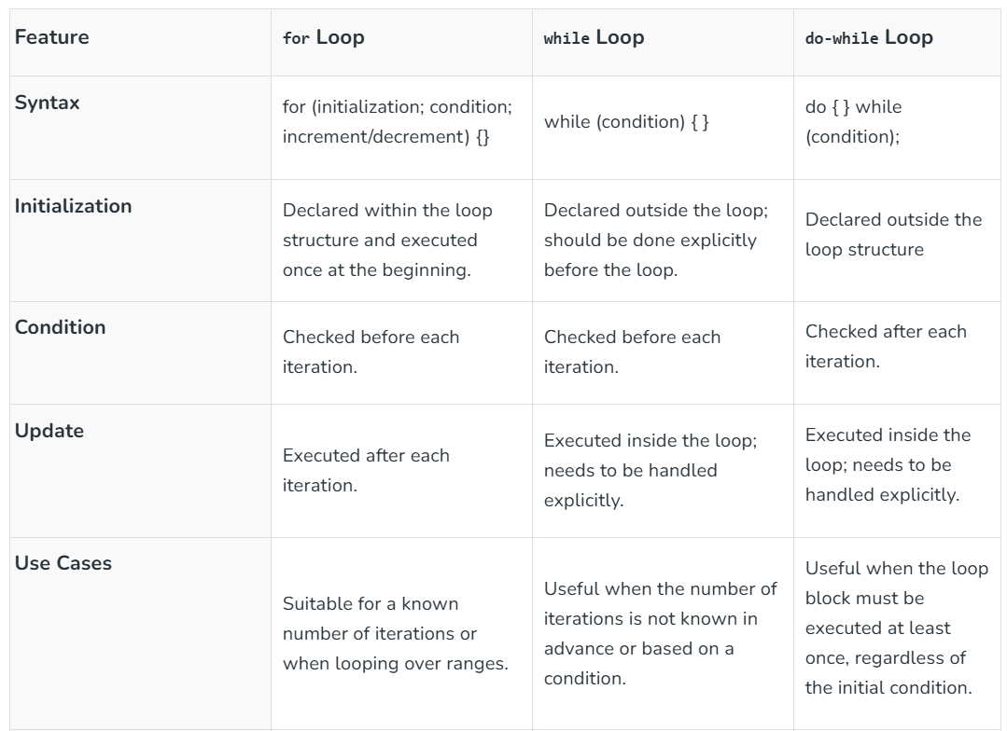

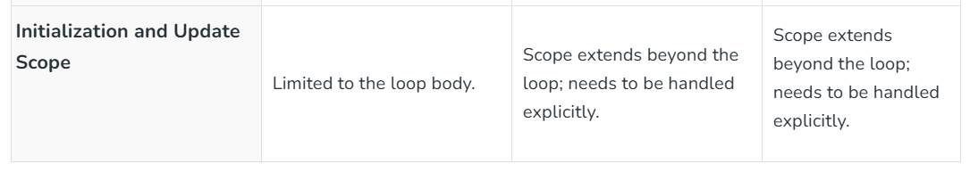

**5. How do JavaScript functions work, and what is the difference between function declarations and function expressions?**

* A function declaration also known as a function statement declares a function with a function keyword. The function declaration must have a function name.
* Function declaration does not require a variable assignment as they are standalone constructs and they cannot be nested inside a functional block.
* These are executed before any other code.
* The function in the function declaration can be accessed before and after the function definition.

// Function Declaration

**function** geeksforGeeks(paramA, paramB) {

**return** paramA + paramB;

}

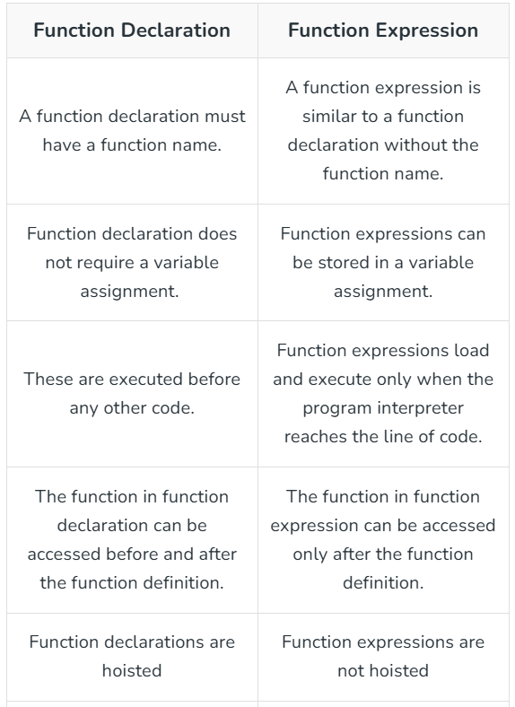

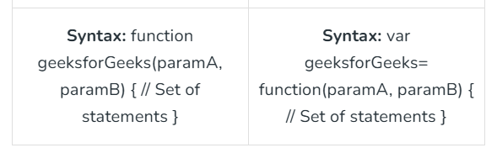

**6. Explain the process of creating, accessing, and modifying objects in JavaScript.**

**8. How can you create and manipulate date objects in JavaScript? Explain with examples.**

Date objects are created with the new Date() constructor.

There are 4 ways to create a new date object:

new Date()

new Date(year, month, day, hours, minutes, seconds, milliseconds)

new Date(milliseconds)

new Date(date string)

new Date()

new Date()

creates a new date object with the current date and time:

**Example**

const d = new Date();

Date objects are static. The computer time is ticking, but date objects are not.

new Date(year, month, ...)

new Date(year, month, ...)

creates a new date object with a specified date and time.

7 numbers specify year, month, day, hour, minute, second, and millisecond (in that order):

**7. Describe the different ways to handle events in JavaScript. Provide examples.**

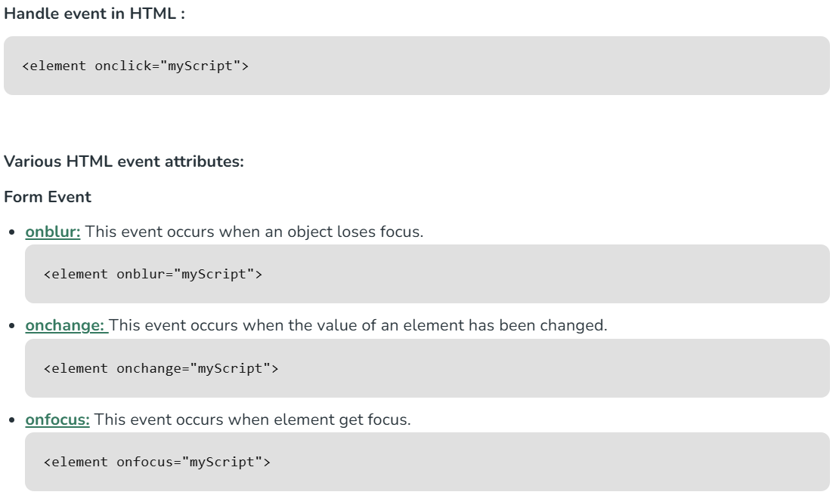

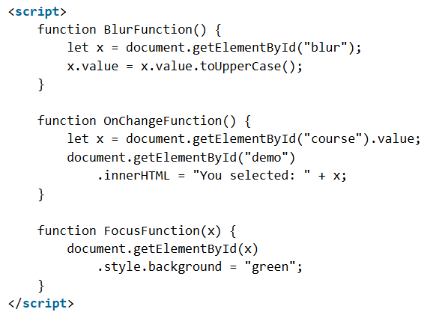

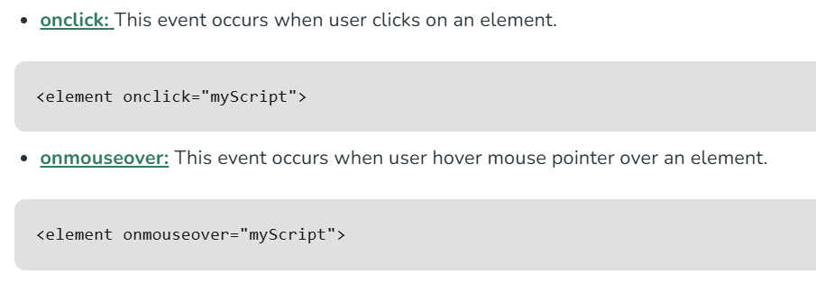

**9. Discuss the different dialog boxes available in JavaScript and their use cases.**

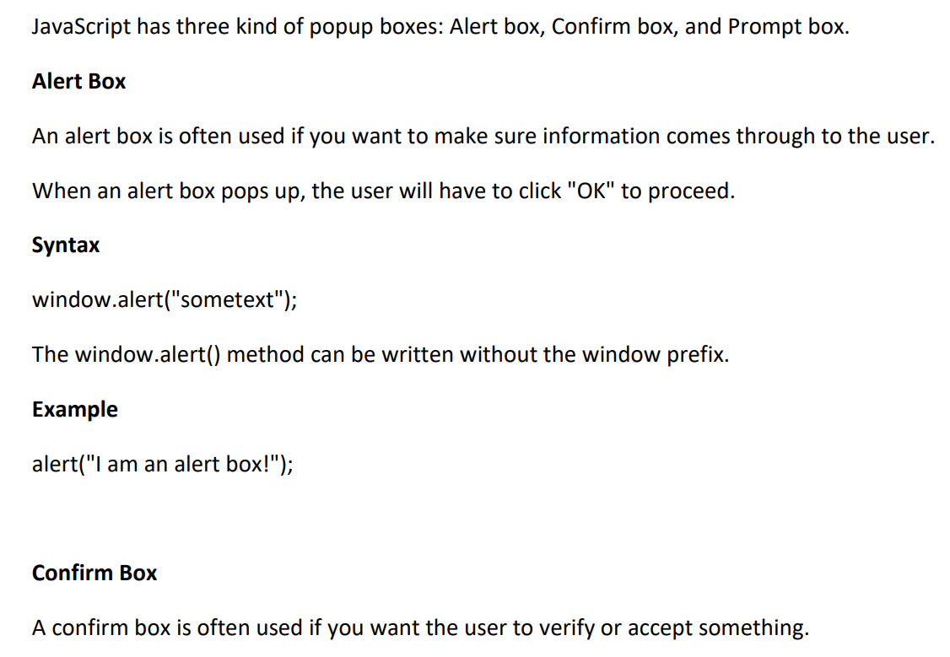

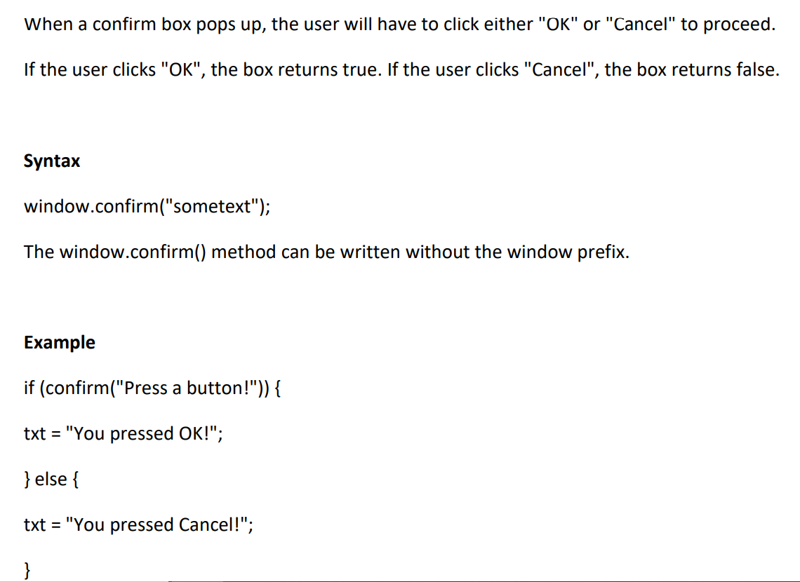

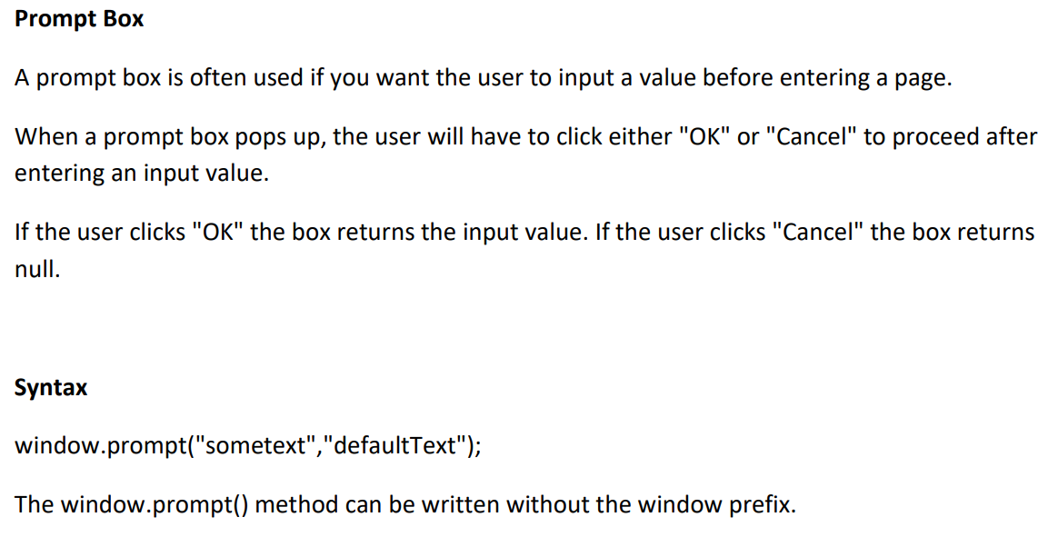

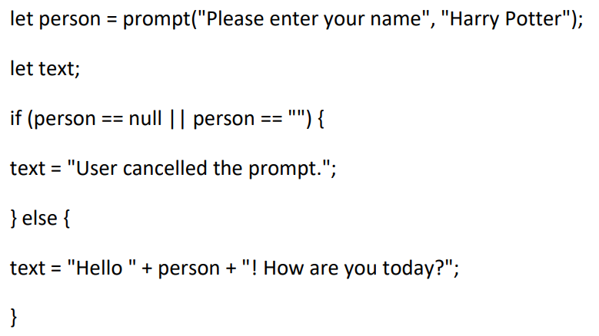

**10. Explain the purpose and use of conditional statements in JavaScript. Provide examples of if, else, else if, and switch statements.**

